Actel jtag的Vpump电路
-

Vpump warning
在用flashPro烧写时，出现warning信息：
Warning: programmer '12611' : Vpump has been selected on programmer AND an externally provided Vpump has also been detected. Using externally provided Vpump voltage source.
对应的jtag电路如下：
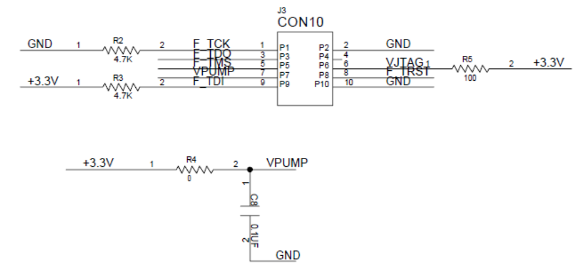

如何连接Vpump
在Actel的《In-System Programming (ISP) of Actel’s Low-Power Flash Devices Using FlashPro3》文档中有介绍Vpump的内容，如下：
Low-power flash devices support on-chip charge pumps, and therefore require only a single 3.3 V
programming voltage for the VPUMP pin during programming. When the device is not being
programmed, the VPUMP pin can be left floating or can be tied (pulled up) to any voltage between
0 V and 3.6 V. During programming, the target board or the FlashPro3 programmer can provide
VPUMP. FlashPro3 is capable of supplying VPUMP to a single device. If more than one device is to be
programmed using FlashPro3 on a given board, FlashPro3 should not be relied on to supply the
VPUMP voltage.
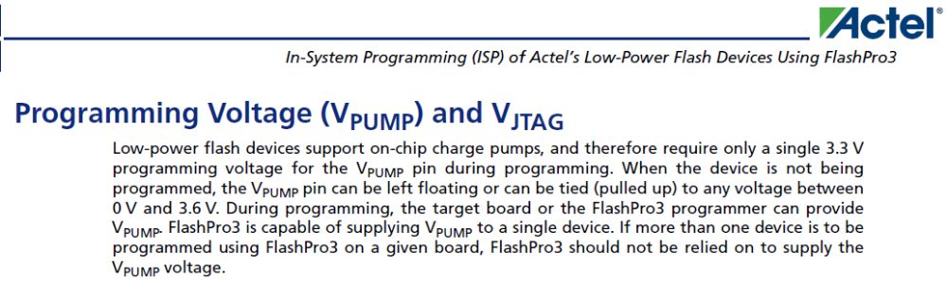
Actel的问题回复中有讲Vpump的问题：
ID:SL5595Devices:Axcelerator, RTAX-DSP, RTAX-S/SL
The internal charge pump generates the voltage that drives the isolation transistors of the logic modules. It turns on when the VCCA supply is powered on and turns off when either the VCCA supply is powered off or the Vpump pin is powered up to greater than 3.3V. The Vpump is recommended to be greater than 3.3V (3.3V to 3.6V) if the customer decides to use the external pump instead of the internal pump. If you use external supply for Vpump it will reduce the current Iccda (Vpump current is included in Iccda). Refer to RTAX-S/L datasheet for Iccda range.
There’s no power sequencing requirements on Vpump. If the external Vpump is powered first, the device would initialize with the external Vpump. But if the external Vpump is powered after the other power supplies, the device will initialize with the internal charge pump and switch to the external Vpump once it exceeds 3.3V.

结论
如果是单个fpga芯片，可以将Vpump悬空。

